1. 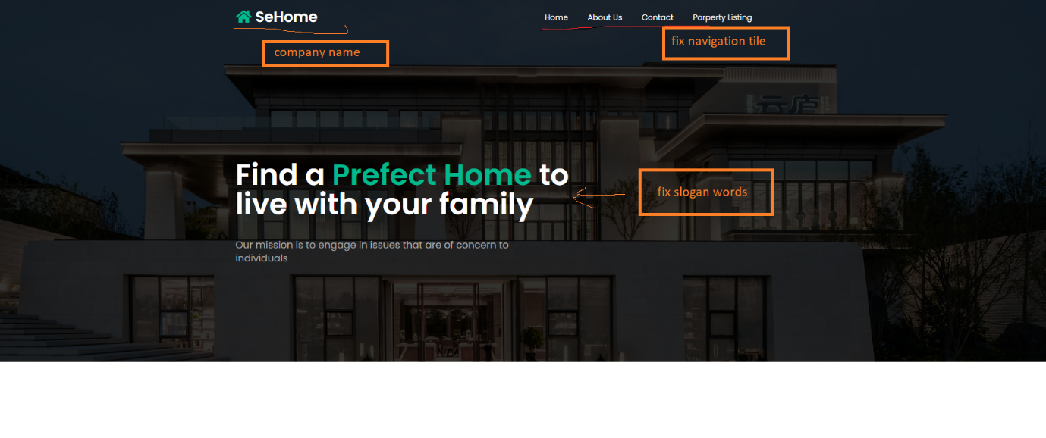Header part
2. Company description

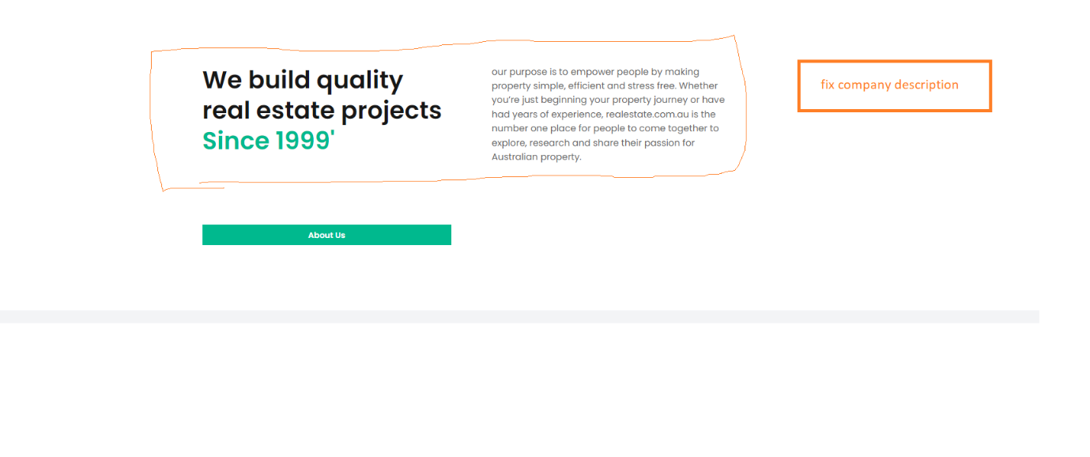

1. Choose property types

1. Property listing, give me the images of every property, detail like (address, numbers of beds, bathrooms, car parks) and description

1. Banner

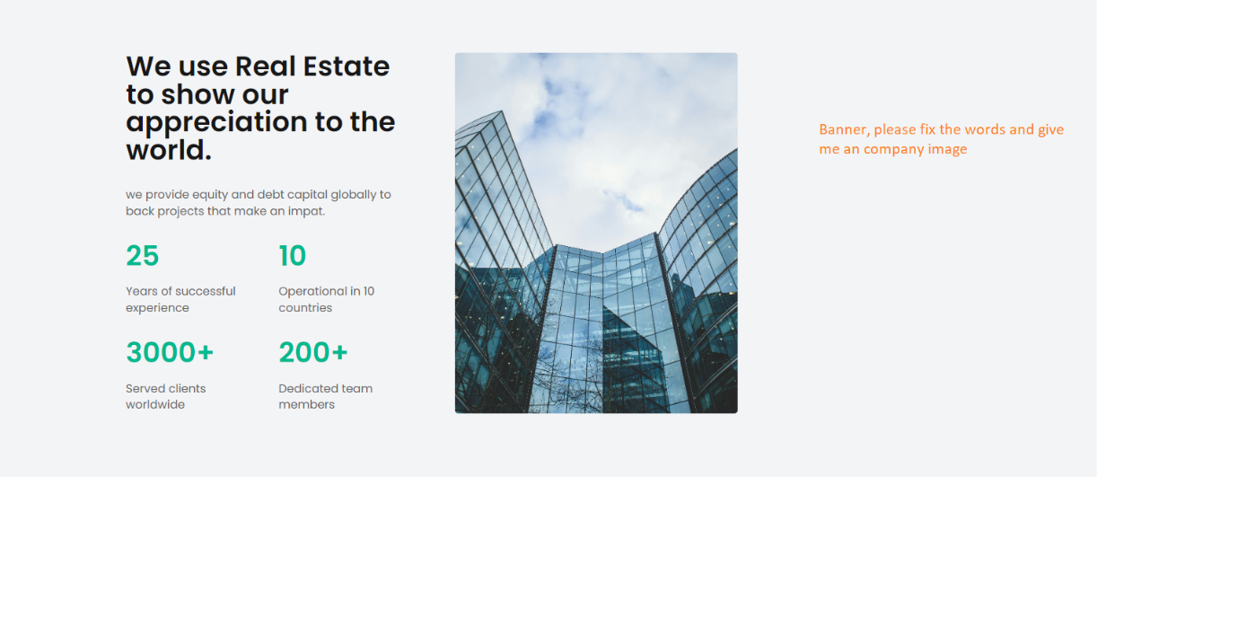

1. Destinations people most love, please consider if we need this part, if not we can remove it. Please give me the images and location if we need this part.

1. Testimonials, think about the clients positive feedback and give the profiles under the feedback

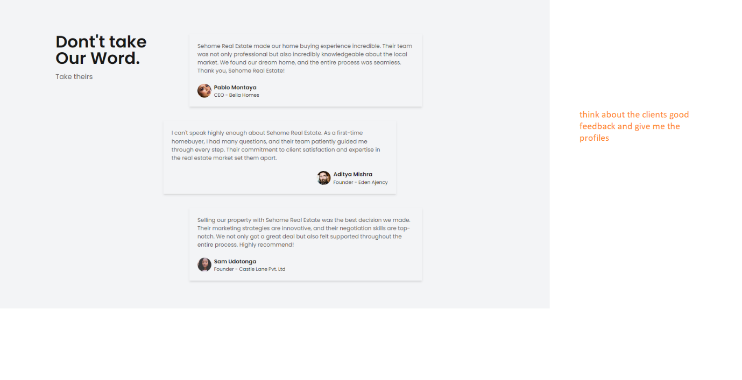

1. Footer

